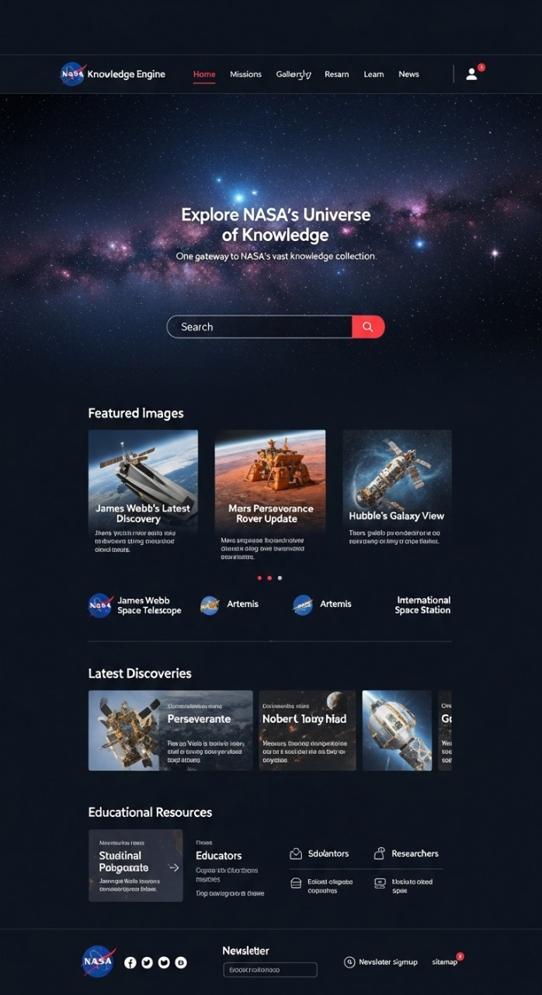

<!-- Project: NASA Knowledge Engine (Full project structure for GitHub)

Files included below:

- index.html

- /assets/ (place images, logos here)

- css/style.css

- js/script.js

- README.md

Add the provided design image to the assets folder if you want a background preview.

-->

<!-- =================== index.html =================== -->

<!doctype html>

<html lang="en">

<head>

<meta charset="utf-8" />

<meta name="viewport" content="width=device-width, initial-scale=1" />

<title>NASA Knowledge Engine</title>

<link rel="preconnect" href="https://fonts.googleapis.com">

<link rel="preconnect" href="https://fonts.gstatic.com" crossorigin>

<link href="https://fonts.googleapis.com/css2?family=Inter:wght@300;400;600;700;800&display=swap" rel="stylesheet">

<link rel="stylesheet" href="css/style.css">

</head>

<body>

<header class="site-header">

<div class="container header-inner">

<div class="brand">

<img src="assets/nasa-logo.svg" alt="NASA" class="logo" />

<span class="brand-text">Knowledge Engine</span>

</div>

<nav class="main-nav">

<a class="active" href="#">Home</a>

<a href="#missions">Missions</a>

<a href="#gallery">Gallery</a>

<a href="#research">Research</a>

<a href="#learn">Learn</a>

<a href="#news">News</a>

</nav>

<div class="user-actions">

<button class="icon-btn">🔔</button>

<button class="avatar">👤</button>

<button class="mobile-toggle" aria-label="menu">☰</button>

</div>

</div>

</header>

<main>

<!-- Hero -->

<section class="hero">

<div class="hero-inner container">

<h1>Explore NASA's Universe of Knowledge</h1>

<p class="subtitle">One gateway to NASA's vast knowledge collection.</p>

<form class="search" onsubmit="return false;">

<input type="search" placeholder="Search" aria-label="Search NASA knowledge" id="search-input">

<button class="search-btn" aria-label="Search">🔍</button>

</form>

</div>

</section>

<!-- Featured Images -->

<section id="gallery" class="section featured">

<div class="container">

<h2>Featured Images</h2>

<div class="carousel" id="featuredCarousel">

<button class="carousel-prev" aria-label="previous">‹</button>

<div class="carousel-track">

<article class="card">

<img src="assets/jwst.jpg" alt="James Webb"/>

<h3>James Webb's Latest Discovery</h3>

<p class="muted">Short description of the discovery or image.</p>

</article>

<article class="card">

<img src="assets/mars.jpg" alt="Mars rover"/>

<h3>Mars Perseverance Rover Update</h3>

<p class="muted">Brief update about Perseverance activities.</p>

</article>

<article class="card">

<img src="assets/hubble.jpg" alt="Hubble"/>

<h3>Hubble's Galaxy View</h3>

<p class="muted">A look into galaxy images captured by Hubble.</p>

</article>

</div>

<button class="carousel-next" aria-label="next">›</button>

</div>

<div class="badges">

<img src="assets/jwst-badge.png" alt="James Webb"/>

<img src="assets/artemis-badge.png" alt="Artemis"/>

<img src="assets/iss-badge.png" alt="ISS"/>

</div>

</div>

</section>

<!-- Latest Discoveries -->

<section id="discoveries" class="section discoveries">

<div class="container">

<h2>Latest Discoveries</h2>

<div class="discover-grid">

<article class="discover-card">

<img src="assets/space1.jpg" alt="discovery 1">

<h4>Perseverante</h4>

<p class="muted">Short summary about this discovery.</p>

</article>

<article class="discover-card">

<img src="assets/space2.jpg" alt="discovery 2">

<h4>Novel Bio Findings</h4>

<p class="muted">How microgravity affected cells in the study.</p>

</article>

<article class="discover-card">

<img src="assets/space3.jpg" alt="discovery 3">

<h4>Galactic Clouds</h4>

<p class="muted">New data on interstellar medium.</p>

</article>

</div>

</div>

</section>

<!-- Educational Resources (using provided NASA resources) -->

<section id="research" class="section resources">

<div class="container">

<h2>NASA Data & Resources</h2>

<p class="muted">A selection of open-access repositories and lists useful for space biology and life-sciences research.</p>

<ul class="resource-list">

<li>

<strong>608 Full‑text Space Biology Publications (CSV)</strong>

<div class="desc">A CSV listing 608 open access space biology articles (download and open locally to see titles and links).</div>

<a class="small-link" href="#">Download CSV</a>

</li>

<li>

<strong>NASA Open Science Data Repository</strong>

<div class="desc">Access to data from 500+ biological experiments conducted in space and for space exploration.</div>

<a class="small-link" href="#">Open OSDR</a>

</li>

<li>

<strong>NASA Space Life Sciences Library (NSLSL)</strong>

<div class="desc">Consolidated space life sciences literature supporting research on the effects of space on biological systems.</div>

<a class="small-link" href="#">Visit NSLSL</a>

</li>

<li>

<strong>NASA Task Book</strong>

<div class="desc">Descriptions and reports on projects supported by NASA BPS and HRP: progress, final reports, and publications.</div>

<a class="small-link" href="#">Explore Task Book</a>

</li>

</ul>

</div>

</section>

</main>

<footer class="site-footer">

<div class="container footer-inner">

<div class="left">

<img src="assets/nasa-logo.svg" alt="NASA" class="logo"/>

<div class="socials">● ○ ○ ○</div>

</div>

<div class="right">

<form class="newsletter" onsubmit="return false;">

<label for="email">Newsletter</label>

<input id="email" type="email" placeholder="you@domain.com">

<button>Sign up</button>

</form>

</div>

</div>

</footer>

<script src="js/script.js"></script>

</body>

</html>

<!-- =================== css/style.css =================== -->

/* Save this file as css/style.css */

:root{

--bg:#071021;

--panel: rgba(255,255,255,0.03);

--muted: rgba(255,255,255,0.6);

--accent: #ff4b57;

--glass: rgba(255,255,255,0.03);

}

*{box-sizing:border-box}

html,body{height:100%;margin:0;font-family:Inter, system-ui, -apple-system, 'Segoe UI', Roboto, 'Helvetica Neue', Arial}

body{background:linear-gradient(180deg,var(--bg),#06101a);color:#fff}

.container{max-width:1100px;margin:0 auto;padding:28px}

.site-header{backdrop-filter: blur(6px);border-bottom:1px solid rgba(255,255,255,0.03);position:sticky;top:0;background:linear-gradient(180deg,rgba(0,0,0,0.25),transparent)}

.header-inner{display:flex;align-items:center;justify-content:space-between}

.brand{display:flex;gap:12px;align-items:center}

.brand .logo{height:34px}

.brand-text{font-weight:700}

.main-nav a{margin:0 10px;color:rgba(255,255,255,0.8);text-decoration:none}

.main-nav a.active{color:var(--accent);border-bottom:2px solid rgba(255,255,255,0.04)}

.user-actions{display:flex;gap:8px;align-items:center}

.icon-btn, .avatar, .mobile-toggle{background:none;border:1px solid rgba(255,255,255,0.04);padding:6px 10px;border-radius:8px;color:#fff}

.mobile-toggle{display:none}

/* Hero */

.hero{min-height:420px;display:flex;align-items:center;background-image:url('../assets/hero-bg.jpg');background-size:cover;background-position:center;padding:60px 0}

.hero-inner{text-align:center;margin:0 auto;color:#fff}

.hero h1{font-size:36px;margin:0 0 10px}

.subtitle{color:var(--muted);margin-bottom:20px}

.search{display:inline-flex;align-items:center;border-radius:40px;background:var(--glass);padding:6px;border:1px solid rgba(255,255,255,0.06)}

.search input{background:transparent;border:0;padding:12px 18px;width:340px;color:#fff;outline:none}

.search-btn{border:0;background:var(--accent);color:#fff;padding:10px 14px;border-radius:28px;margin-right:4px}

.section{padding:56px 0}

.section h2{margin:0 0 18px}

.carousel{display:flex;align-items:center;gap:12px}

.carousel-track{display:flex;gap:18px;overflow:hidden}

.card{min-width:260px;background:var(--panel);padding:12px;border-radius:12px}

.card img{width:100%;height:150px;object-fit:cover;border-radius:8px}

.card h3{margin:10px 0 6px}

.muted{color:var(--muted);font-size:14px}

.badges img{height:40px;margin-right:8px}

.discover-grid{display:grid;grid-template-columns:repeat(3,1fr);gap:18px}

.discover-card{background:var(--panel);padding:12px;border-radius:12px}

.discover-card img{width:100%;height:120px;object-fit:cover;border-radius:8px}

.resource-list{list-style:none;padding:0;margin:18px 0 0}

.resource-list li{background:var(--panel);padding:16px;border-radius:8px;margin-bottom:12px}

.resource-list .desc{color:var(--muted);font-size:14px;margin-top:6px}

.small-link{display:inline-block;margin-top:8px;color:var(--accent);text-decoration:none}

.site-footer{border-top:1px solid rgba(255,255,255,0.03);padding:28px 0;margin-top:48px}

.footer-inner{display:flex;justify-content:space-between;align-items:center}

.newsletter input{padding:8px 10px;border-radius:8px;border:1px solid rgba(255,255,255,0.06);background:transparent;color:#fff}

.newsletter button{margin-left:8px;padding:8px 12px;border-radius:8px;border:0;background:var(--accent)}

/* Responsive */

@media(max-width:900px){

.discover-grid{grid-template-columns:repeat(2,1fr)}

.main-nav{display:none}

.mobile-toggle{display:block}

}

@media(max-width:600px){

.discover-grid{grid-template-columns:1fr}

.carousel-track{gap:12px}

.hero h1{font-size:26px}

.search input{width:170px}

}

/* =================== js/script.js =================== */

/* Save this file as js/script.js */

(function(){

// Simple carousel logic

const track = document.querySelector('.carousel-track');

if(!track) return;

let index = 0;

const prev = document.querySelector('.carousel-prev');

const next = document.querySelector('.carousel-next');

const cards = Array.from(track.children);

const cardWidth = cards[0].getBoundingClientRect().width + 18;

function update(){

track.style.transform = translateX(${-index * cardWidth}px);

}

prev.addEventListener('click', ()=>{ index = Math.max(0, index-1); update(); });

next.addEventListener('click', ()=>{ index = Math.min(cards.length-1, index+1); update(); });

// Mobile menu toggle

const toggle = document.querySelector('.mobile-toggle');

toggle && toggle.addEventListener('click', ()=>{

const nav = document.querySelector('.main-nav');

if(nav.style.display==='flex') nav.style.display='none'; else nav.style.display='flex';

});

})();

<!-- =================== README.md =================== -->

# NASA Knowledge Engine — Frontend Prototype

This repository contains a responsive prototype of the *NASA Knowledge Engine* homepage (HTML/CSS/JS). It's built as a static site to be deployed on GitHub Pages or any static host.

## Project structure

/ (repo root)

index.html

css/style.css

js/script.js

assets/ # put logos and images here (JWST, Hubble, badges, hero-bg.jpg etc)

README.md

## How to use

1. Create the folders css, js, and assets.

2. Save the code blocks into the corresponding files.

3. Add images to assets/ (placeholders used: hero-bg.jpg, jwst.jpg, mars.jpg, hubble.jpg, space1.jpg, space2.jpg, space3.jpg, nasa-logo.svg, badges)

4. Open index.html in a browser.

5. Commit and push to GitHub. Optionally enable GitHub Pages on the main branch.

## Notes & next steps

- Replace placeholder image files with high-resolution NASA images (ensure licensing compliance).

- Hook the search form to a real search backend or use client-side indexing.

- Add accessibility improvements and unit tests if needed.

- Integrate the CSV and NASA repositories links for real downloads.

<!-- End of document -->